System Description

1. Cars' LEDs will be changed every five seconds starting from Green then yellow then red then yellow then Green.
2. The Yellow LED will blink for five seconds before moving to Green or Red LEDs.
3. If Switch for Pedestrain is pressed we will go to Pedestarin mode.
4. Before that we will check when this switch is pressed
5. For all states there is different scenario
6. I used some drivers to help me for this project and I will explain them in System Design

System Design

MCAL (GPIO_Driver , External Interrupt_Driver , Timer0_Driver )

Application Layer

HAL (LED_Driver , Btn_Driver )

Service Layer

Flow Chart

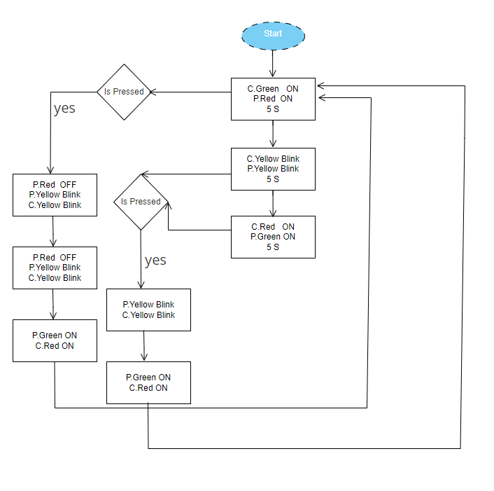

System Constraints

No system constraints